Tech Talk: Microsoft Excel

Table of Contents
- Useful Shortcuts
- Sorting
- Filters
- Conditional Formatting
- Dealing with Duplicates
  - Find Duplicates
  - Remove Duplicates
- PivotTables

1. Useful Shortcuts
Moving around
Arrow Keys – move in the direction you pressed
Ctrl+Arrow Keys – select the last cell in the data set in the direction you press
Ctrl+Home – select the top left cell of the data (usually cell A1)
Ctrl+End – select the bottom right cell of the data
Ctrl+A - select all cells
Highlighting cells
In general, you can add “Shift” to the above shortcuts to highlight all of the cells in the range.
Shift+Arrow Keys – highlight the current cell and the next consecutive cell in the direction you press
Ctrl+Home – highlight the current cell and all cells between it and the top left cell of the data.
Ctrl+End – highlight the current cell and all cells between it and the bottom right cell of the data.

2. Sorting
You can sort your data set in various ways by going to the Data tab in the ribbon and clicking the Sort button.
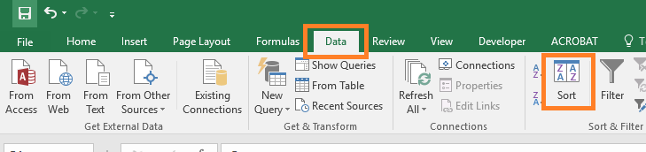
This will bring up a dialog box that shows you various ways to sort your data.
- The buttons at the top of the box allow you to add additional sorting levels and organize their priority
- The dropdown menus in the Column section allow you to choose which columns you want to sort by.
- The dropdown menus in the Order section allow you to choose the sorting order (i.e. ascending, descending, or custom orders).
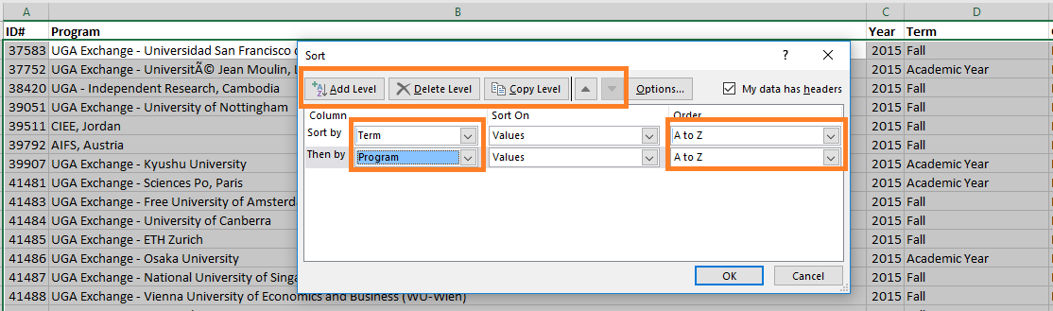

3. Filters
Filters will let you hide all rows except for the specific ones you want to see. You can access filters by clicking on the Data tab on the ribbon and clicking on the Filter button.
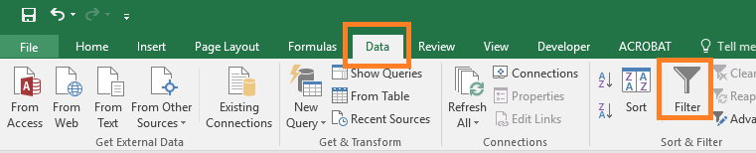
After clicking the Filter button, little “down arrow” buttons will appear at the top of each column.
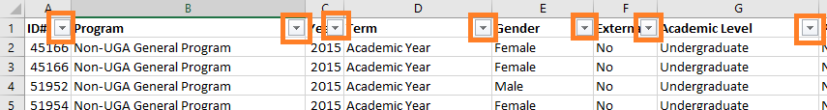
Clicking on these arrows will allow you to apply a filter (basically, tell Excel which rows you want to see, and which ones you don’t want to see).
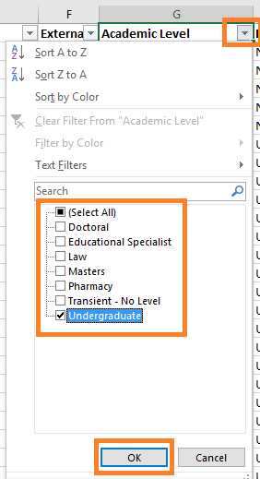
In this example, I specified that I only want to see records that have a value of “Undergraduate” for the Academic Level column.
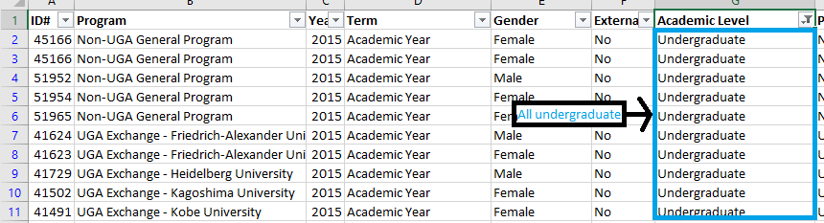
Filters on multiple columns can be combined. For example, you could filter to only show Undergraduate students and once you have that, filter even further to only show Male students.

4. Conditional Formatting
Instead of manually formatting a bunch of cells by hand, you can specify certain conditions that will cause cells to be formatted automatically. For example, you might want every cell that says “No” in a spreadsheet to be colored red.
To conditionally format your data, first select the cells you want to format.
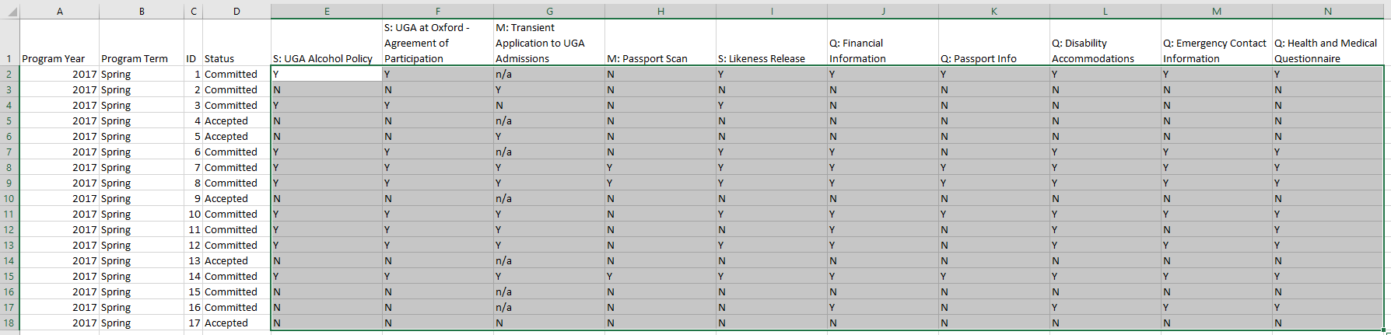
Next, click on the Home tab in the ribbon and click on the Conditional Formatting dropdown menu, hover over Highlight Cells Rules and then click on Equal To…
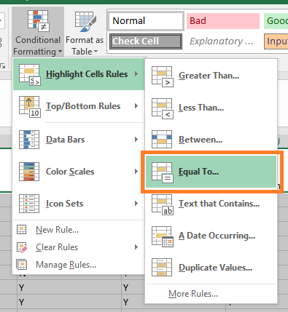
This will open up a dialog box where you can specify your criteria and how you want the cell to be formatted. In this example, I have said that I want all cells that contain “N” to be formatted with a “Light Red Fill with Dark Red Text”. You can change the formatting by clicking on the dropdown menu (for example, you might want cells that are “Y” to be green).
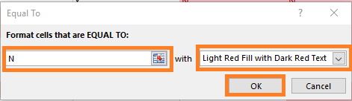
Click to OK button to see your results.
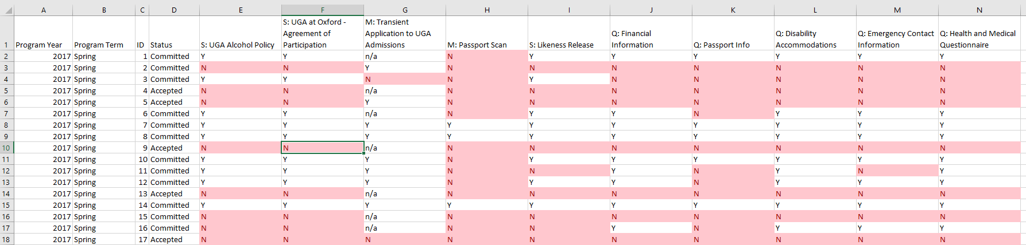
Note: Conditional formatting will overwrite manual formatting. (i.e. if you manually colored one of the “N” boxes blue, it would still appear red because the conditional formatting takes priority).

5. Dealing with Duplicates

a. Find Duplicates
You might want to check your data set for duplicates, but want to review them first instead of deleting them automatically. We can use conditional formatting to accomplish this.
First, select the columns that you want to check for duplicates on. In this example, I want to see if the student ID column has any duplicates.
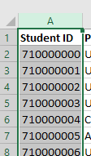
Go to the Home tab in the ribbon and click on the Conditional Formatting dropdown menu, hover over Highlight Cells Rules and then click on Duplicate Values…
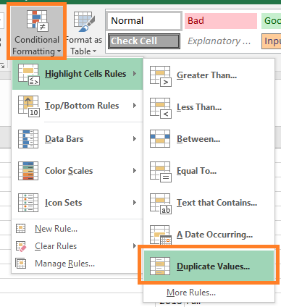
This will open a dialog box allowing you to specify what you want to highlight (duplicate or unique values) and how you want to color them.
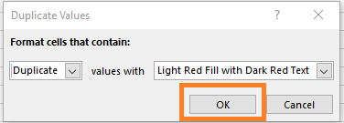
Click OK to view your results.
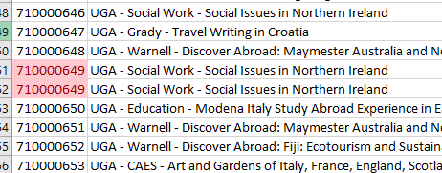

b. Remove Duplicates
Caution: Excel will not give you the opportunity to review duplicates if you use the Remove Duplicates button. Be very careful that you don’t accidentally delete useful data.
Sometimes you may want to remove duplicate values from your data set. There is a built in function to do this found by going to the Data tab on the ribbon and clicking the Remove Duplicates button.
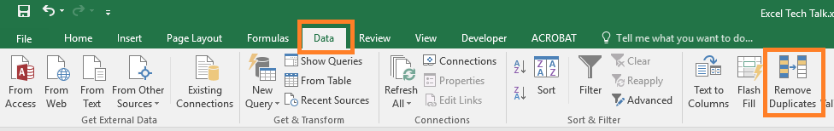
A dialog box will appear allowing you to select the criteria for determining a duplicate. By default, every box is checked meaning that Excel will only remove rows that are exact duplicates in each column. However, you may want to specify different criteria for what a duplicate is. In this example, I have specified that any application that has the same student ID number, year, and term should be considered a duplicate.
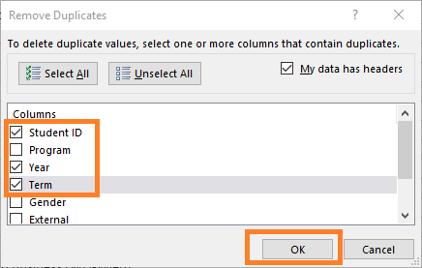
After clicking the OK button, Excel will search your sheet (or selection) for the specified criteria. If it finds any duplicates, it will automatically delete them.
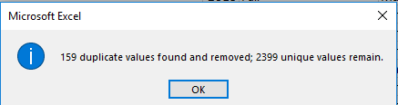

6. PivotTables
You might not want to look at all of the data but just want a nice little table giving a summary of your data. This can easily be done using PivotTables.
First, click your mouse in your data set.
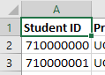
Click on the Insert tab in the ribbon and then click on the PivotTable button.
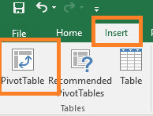
A dialog box will appear. The default settings are fine. Click OK.
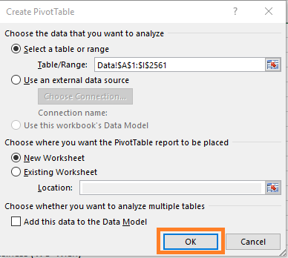
Your PivotTable will be created on a new tab in your workbook.
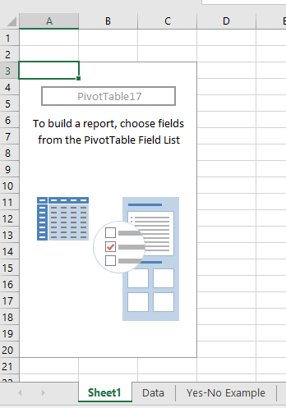
You can specify want you want to see in your table in the PivotTable Fields panel on the right hand side of the screen. Drag and drop the columns into the areas at the bottom:
- Rows: What rows you want to see in your table
- Columns: What columns you want to see in your table
- Filters: Any categories you want to filter on (exclude) in your table
- Values: What numbers you want to see displayed in your table

In this example, I want to see which gender students participate in which types of program (by the program category). I’d also like to be able to see this for each college.

In order to do this, I’ve put the following in each category:
- Rows: Program Category
- Columns: Gender
- Filters: College
- Values: Student ID
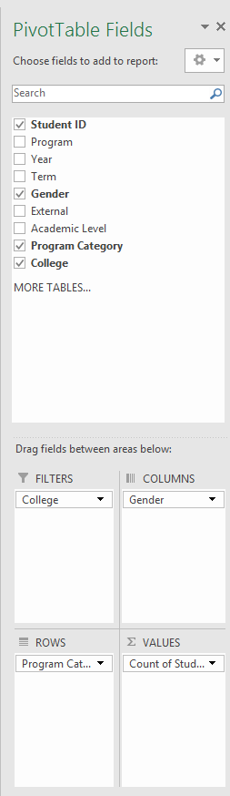
Special Note: By default, if you put a number into the Values section, it will sum them together. In this situation, we just want to count the number of students in each category, so we need to click on the Students item in the Values section, select Value Field Settings.
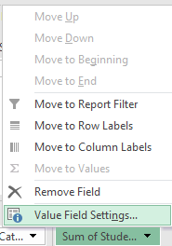
This will open a dialog box where can change “Sum” to “Count”.
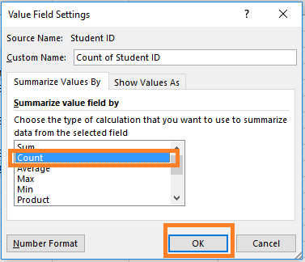

Now we see the table in all of its glory!
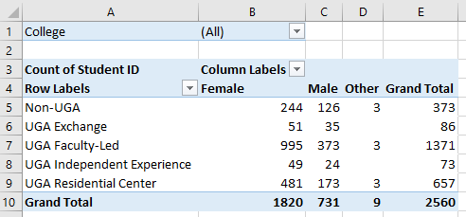

You can filter on the college by clicking on the Filter icon next to college.
